**QUESTION TWO**

**iii) SIMULATION (the potential impact on public health policies.) by using Descriptive Statistics**

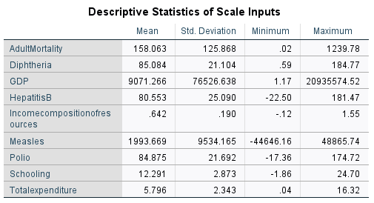

**1. Adult Mortality:**

* **Mean:** 158.063
* **Standard Deviation:** 125.868
* **Implications:** High adult mortality rates suggest significant health challenges in the population. Policies should focus on improving healthcare access, enhancing preventive care, and addressing the underlying causes of adult mortality (e.g., chronic diseases, injuries, and infectious diseases). Initiatives could include expanding health insurance coverage, increasing funding for healthcare facilities, and promoting health education.

**2. Diphtheria Immunization Rates:**

* **Mean:** 85.084
* **Standard Deviation:** 21.104
* **Implications:** With a mean immunization rate of 85.084%, there is a need for policies that ensure high vaccination coverage to prevent outbreaks. Public health campaigns should focus on increasing awareness about the importance of vaccinations and addressing barriers to access. Strategies could include mobile vaccination clinics, school-based immunization programs, and community outreach.

**3. Gross Domestic Product (GDP):**

* **Mean:** 9071.266
* **Standard Deviation:** 76526.638
* **Implications:** The significant variation in GDP indicates disparities in economic resources available for health. Policies should aim to stimulate economic growth through job creation, investment in infrastructure, and support for small businesses. Economic growth can lead to increased tax revenues, which can then be reinvested into health services and social programs.

**4. Hepatitis B Immunization Rates:**

* **Mean:** 80.553
* **Standard Deviation:** 25.090
* **Implications:** The mean immunization rate for Hepatitis B suggests that there is room for improvement. Public health policies should focus on increasing vaccination rates, particularly among high-risk populations. Educational campaigns about the importance of vaccination and access to vaccines are crucial.

**5. Income Composition of Resources:**

* **Mean:** 0.642
* **Standard Deviation:** 0.190
* **Implications:** A lower income composition indicates potential inequalities in resource distribution. Policies should focus on reducing income inequality through progressive taxation, social safety nets, and targeted economic programs for disadvantaged communities. Improving income distribution can lead to better health outcomes across the population.

**6. Measles Immunization Rates:**

* **Mean:** 1993.669
* **Standard Deviation:** 9534.165
* **Implications:** The high variability in measles immunization rates suggests significant disparities in vaccination coverage. Public health policies should prioritize increasing measles vaccination rates through awareness campaigns, school mandates, and community engagement initiatives. Addressing misinformation about vaccines is also crucial.

**7. Polio Immunization Rates:**

* **Mean:** 84.875
* **Standard Deviation:** 21.692
* **Implications:** Similar to diphtheria, maintaining high polio vaccination rates is essential for preventing outbreaks. Policies should support ongoing vaccination programs and ensure that vulnerable populations have access to vaccines.

**8. Schooling:**

* **Mean:** 12.291
* **Standard Deviation:** 2.873
* **Implications:** Higher levels of education are generally associated with better health outcomes. Policies should focus on improving educational access and quality, particularly for marginalized groups. Health education programs in schools can also promote healthy behaviors among children and adolescents.

**9. Total Expenditure on Health:**

* **Mean:** 5.796
* **Standard Deviation:** 2.343
* **Implications:** The mean expenditure indicates the level of investment in health services. Policies should advocate for increased health funding, ensuring that expenditures are directed towards preventive care, mental health services, and chronic disease management. Evaluating the effectiveness of current spending can help optimize resource allocation.

**Conclusion**

**Policy Implications:**

The analysis of these socio-economic factors highlights the interconnectedness of health and economic conditions. Public health policies should be multi-faceted and consider the broader social determinants of health. ***Key recommendations include:***

* **Integrated Health and Economic Policies:** Develop policies that link economic growth with health improvements, ensuring that economic benefits translate into better health outcomes.
* **Targeted Interventions:** Focus on high-risk populations and areas with low vaccination rates to improve health equity.
* **Community Engagement:** Involve communities in health promotion efforts to increase awareness and participation in health programs.
* **Monitoring and Evaluation: Continuously monitor health outcomes and the effectiveness of policies to adapt and improve strategies over time.**

**iv) Validate the Model and Perform Sensitivity Analysis**

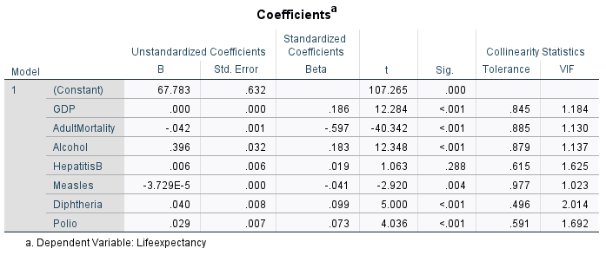

**PREDICTED LIFE EXPECTANCY**

* **The regression equation is:**

**LifeExpectancy=**67.783+0.000(GDP)−0.042(AdultMortality)+0.396(Alcohol)+0.006(HepatitisB)−0.000037(Measles)+0.040(Diphtheria)+0.029(Polio)

**LifeExpectancy=**67.783+(0.000×GDP)+(−0.042×AdultMortality)+(0.396×Alcohol)+(0.006×HepatitisB)+(−3.729×10−5×Measles)+(0.040×Diphtheria)+(0.029×Polio)

=